**Execution Environment:**

Python 3.9 (https://www.python.org/downloads/)

Stable Open-CV Release (python3 -m pip install opencv-python)

Stable Numpy Release (python3 -m pip install numpy)

Stable Scipy and SKlearn (python3 -m pip install -U scikit-learn)

If you are running these on a raspberry pi you need to follow raspberry pi specific installation instructions. I found that appending --index-url <https://www.piwheels.org/simple/> as a flag to pip made installations much easier on the raspberry pi.

**Algorithm:**

The description of the algorithm is given in the comments in the code. However, here is a quick summary of how it works.

1. Start with the Raw Image

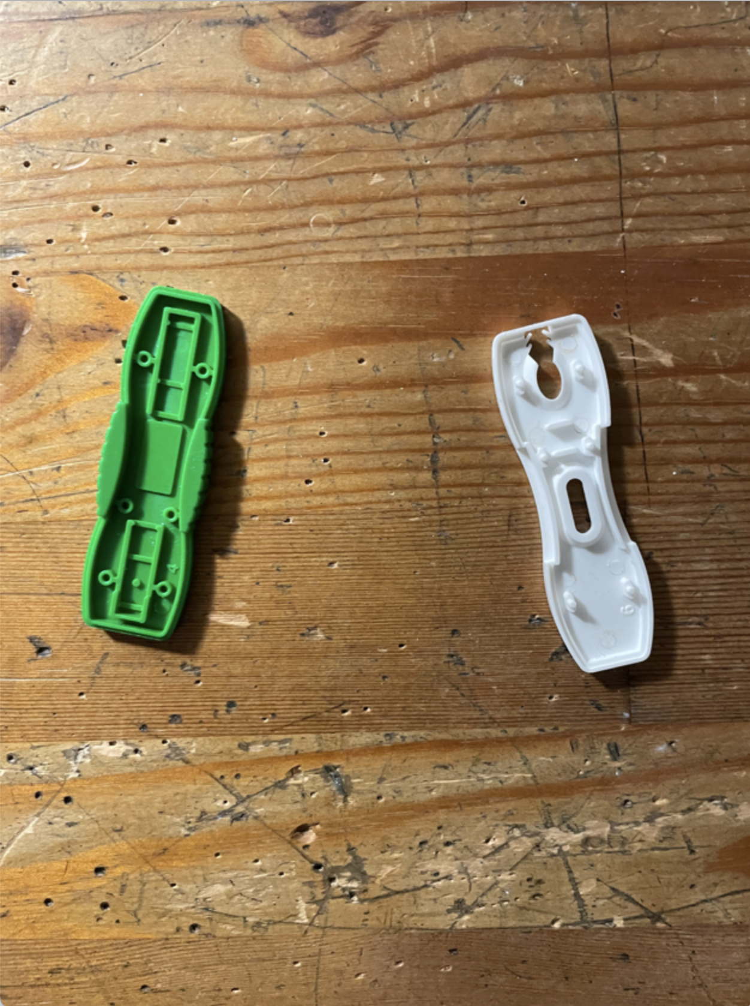

1. Convert the RGB image to the HSV color scale and apply a threshold to only select the white/green cartridges

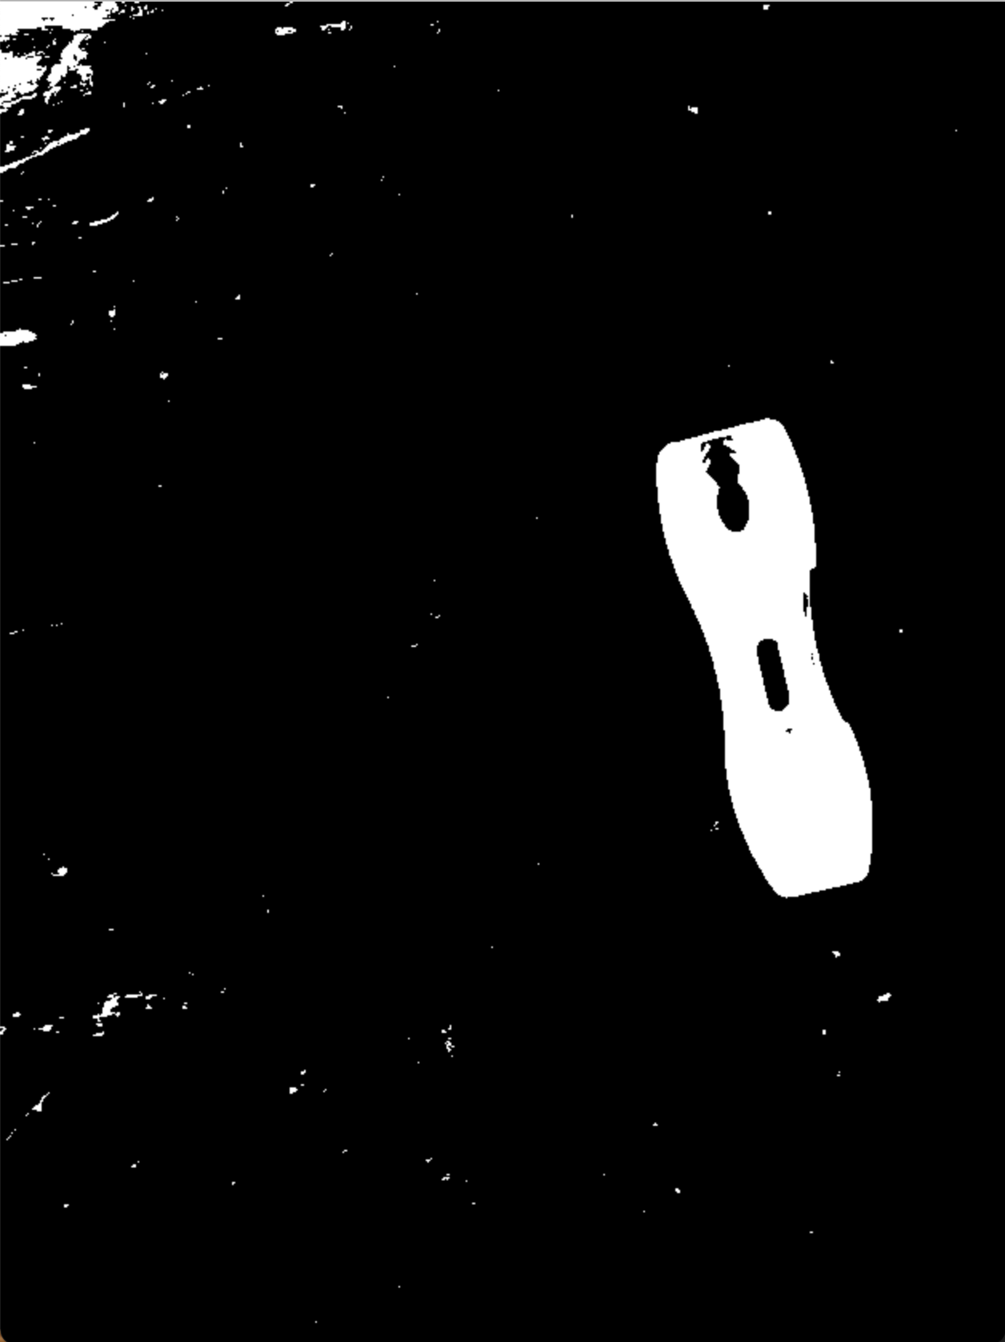

We have segmented the image by color and are only left with the white sample.

1. Detect Contours and fit a Bounding Box

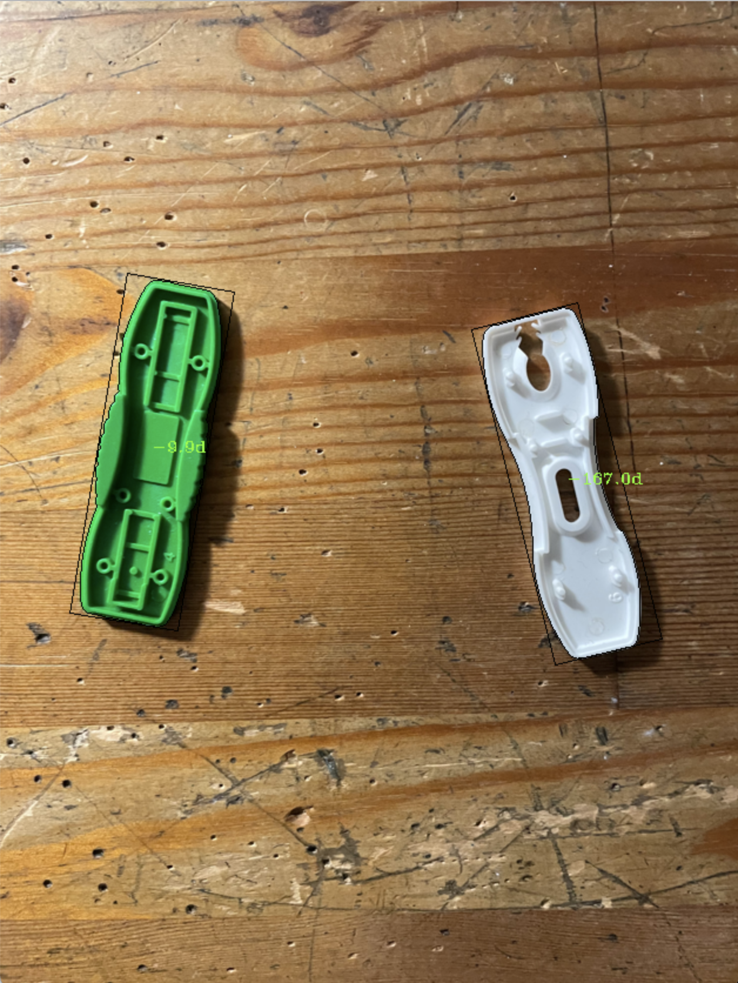

The OpenCV Find Contours function is used to identify the cartridge contours. Then the open cv minimum area rectangle is used to fit a rotated rectangle to the contour. Lastly, the contour moments are calculated, and we use simple relationships to determine the rotation of the contour (see https://en.wikipedia.org/wiki/Image_moment#Examples).

As you can see in the above image, the orientation angles of the contour are labeled in green. The green sample is rotated 9.9 degrees CCW, while the white sample is rotated 167 degrees CCW.

**Face up/ Face Down Detector**

We use statistical learning to determine whether a cartridge is face down or face up.

First, we compute the internal contours of the image, by using a canny edge detector and a contour detector. This is what the internal contours looks like:

**Edges:**

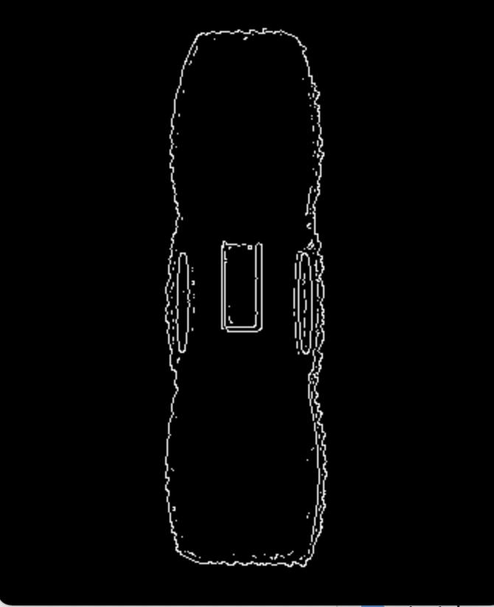

**Internal Features**

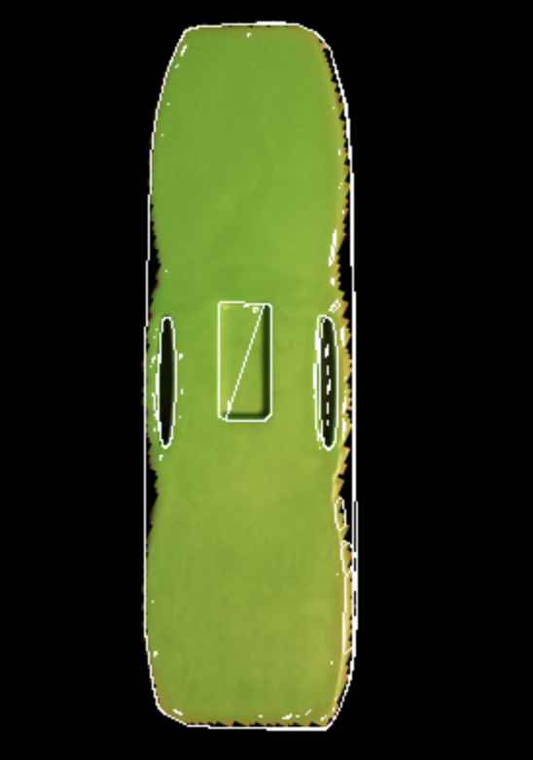

Notice there are about 3 internal contours on the image. These contours are converted into a list of vector features by computing the relative position of the internal contour with respect to the center of the cartridge, and the relative size of the contour with respect to the size of the cartridge.

We do this for every green cartridge in the training set of green cartridges. Now we have a very big list of vectors where every vector resembles a contour on the bottom side of a green cartridge. I approximate this list of vectors/point cloud with a gaussian mixture model.

Now that I have a probabilistic model for the internal contours of the bottom side of a green cartridge, the next time I take a picture of a green cartridge, I can compute the vector representation of the internal contours and compute the likelihood that these new internal contours belong to the gaussian mixture model. If the likelihood is very high, then I know that my cartridge is face down as well. If the likelihood is really low, I know that the cartridge is face up.

**Detailed Description of code raspi_implmentation.py**

Before running rasp_implementation.py we need to run: python3 find_hsv_thresholds.py

This will open up a screen with a camera input and sliders where you can adjust the HSV thresholds for green and white cartridges respectively.

First place a green cartridge under the camera and adjust the sliders such that there is a solid white mask on top of each green cartridges. Record down the values of all the sliders.

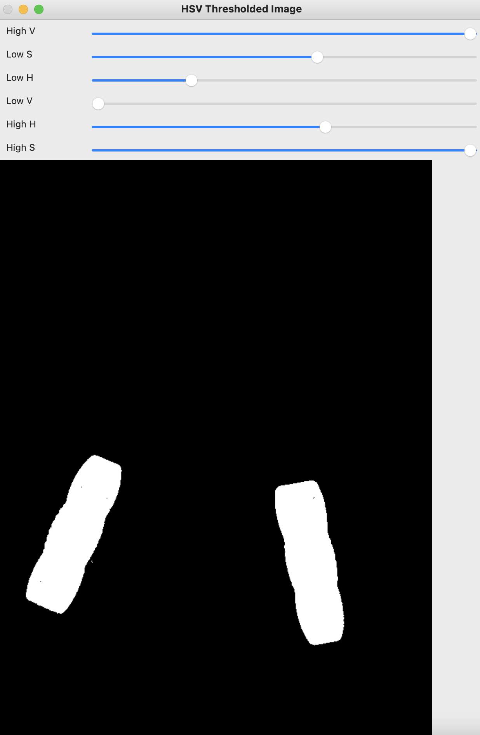

Repeat this with a white cartridge and record all the HSV thresholds for the white cartridge.

Now that we have all the HSV thresholds, edit lines 13, 14 of raspi_implementation.py with the new thresholds:

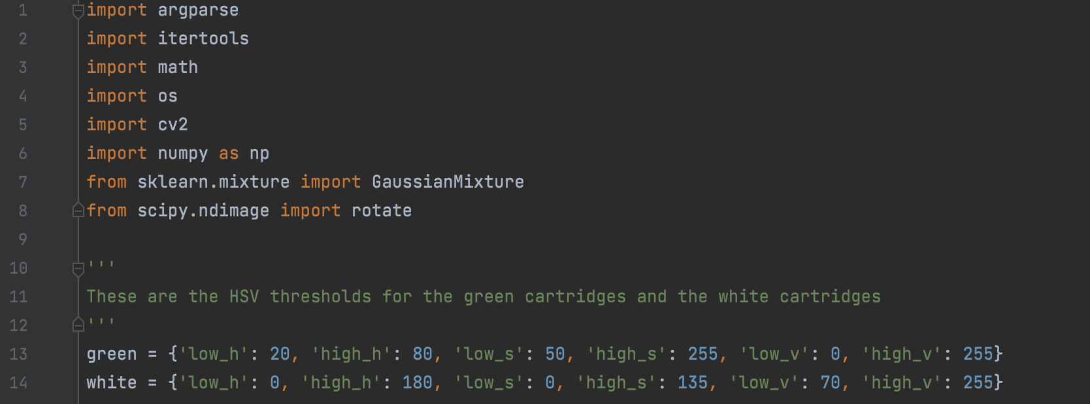

Save the file and close it.

The next step is to collect training images for the face_up/face_down detector.

We can do this by running the rasp_implementation program with the following flag:

python3 raspi_implementation.py --take_green_down_pictures

A frame window will pop up showing a video stream of the raspberry pi camera. Place a green cartridge face down and hit enter after clicking on the frame window. Repeat this 15 times, adjusting the green cartridge’s orientation randomly (and using different green cartridges).

After this process the <https://github.com/neilhazra/CartridgeOrientationDetector/tree/main/training_images/green_down>

Folder should be full of your captured images.

Repeat this process with the white cartridges face down, but instead run the following command:

python3 raspi_implementation.py --take_white_down_pictures

Finally we can run the main program as follows:

python3 raspi_implementation.py –run_detection_algo

Now a frame window will pop up showing the camera stream annotated with the orientation of the cartridge. The angle is written on the cartridge’s bounding rectangle and a large green circle means the cartridge is face up, and a large red circle means the cartridge is face down.

